PROJECT REPORT

ROAD VISION ANALYZER
Traffic Sign and Vehicle Number Plate Detection System
using Classical Computer Vision

Submitted by | BIKRAM KUMAR
Enrolment No. | 24BAI10471
Course | Computer Vision
Institution | VIT UNIVERSITY, BHOPAL
Faculty | Dr. NEHA RATHORE
Month / Year | September 2026

Technologies: Python 3 · OpenCV · NumPy · pytest · (optional) Tesseract OCR
Command-line application · No GUI · No GPU · No internet · No trained AI model

Declaration
I hereby declare that this project, "Road Vision Analyzer — Traffic Sign and Vehicle Number Plate Detection System", is my own work, built from the stated requirements using standard, openly documented Computer Vision techniques. Third-party libraries (OpenCV, NumPy, pytest and the optional Tesseract engine) are used as documented and are listed in the References. Every number reported in this document was produced by running the project; no accuracy figures or dataset statistics have been invented.

Signature: bikramkumar Date: 01.10.2026

Table of Contents
Declaration 1
Table of Contents 1
1. Title 1
2. Abstract 1
3. Introduction 1
4. Problem Statement 1
5. Objectives 1
6. Scope 1
7. Technologies Used 1
8. System Architecture 1
8.1 Module responsibilities 1
8.2 Project structure 1
8.3 Design principles 1
9. Methodology 1
10. Traffic Sign Detection 1
10.1 Colour segmentation (HSV) 1
10.2 Mask cleaning, contours and filtering 1
10.3 Shape analysis 1
10.4 Interior features 1
10.5 Rule-based classification 1
10.6 Heuristic confidence 1
11. Number Plate Detection 1
11.1 Heuristic confidence 1
11.2 Result combination 1
11.3 Output per plate 1
12. OCR Module 1
13. Algorithms 1
14. Implementation 1
14.1 Command-line interface 1
14.2 Error handling 1
14.3 Output formats 1
14.4 Synthetic sample data 1
15. Experimental Results 1
15.1 Setup 1
15.2 Per-image results 1
15.3 Batch summary (measured) 1
15.4 OCR result 1
15.5 Observations and corrections made during development 1
16. Testing 1
16.1 Manual verification 1
17. Limitations 1
18. Future Scope 1
19. Conclusion 1
20. References 1
Appendix A: Requirements Traceability 1
Appendix B: How to Run 1
Appendix C: Sample Terminal Output 1
Appendix D: Sample JSON Report Entry 1

1. Title
Table 1: Project identification
Item | Details
Project title | Road Vision Analyzer — Traffic Sign and Vehicle Number Plate Detection System
Domain | Computer Vision (classical, rule-based; no machine-learning model)
Tasks | Traffic sign detection and classification; vehicle number plate detection with optional OCR
Language / version | Python 3 (verified on Python 3.12.3), project version 1.0.0
Interface | Command line (main.py); runs fully offline; no GUI, GPU, cloud service or paid API
Outputs | Annotated images, cropped plates, terminal report and report.json
Size | About 1,250 lines of Python across 10 source modules, the CLI and 3 test files

2. Abstract
Road Vision Analyzer is a command-line Computer Vision application that analyses road and vehicle images and reports two kinds of objects: traffic signs and vehicle number plates. Traffic signs are located by segmenting red, blue and yellow regions in HSV colour space, cleaning the masks with morphological operations, extracting contours, and describing each candidate by its polygon sides, circularity and enclosing-circle ratio. A rule-based classifier then labels each candidate as STOP, SPEED_LIMIT, NO_ENTRY, WARNING, DIRECTION or UNKNOWN. Number plates are located with Gaussian blur, Canny edge detection, morphological closing and contour filtering by size, aspect ratio, rectangularity and edge density, followed by heuristic ranking and overlap suppression. An optional OCR module (Tesseract) can read the cropped plate; it is never required and never fabricates text.
The system accepts a single image or a folder, saves annotated images and plate crops, prints a structured terminal report with a batch summary, and writes a machine-readable JSON report. On the eight synthetic demonstration images generated by the project it produced the expected result for every image (7 signs and 2 plates found, no failures), and all 20 automated tests pass. Because these images are synthetic and drawn by the same author as the detection rules, the results demonstrate that the pipeline works and are not evidence of real-world accuracy, which has not been measured. Confidence values are rule-based heuristic scores, not machine-learning probabilities.
Keywords: computer vision, traffic sign detection, number plate detection, HSV segmentation, contour analysis, Canny edge detection, rule-based classification, OCR, OpenCV.

3. Introduction
Understanding road scenes is central to driver-assistance systems, automatic traffic monitoring and smart-city applications. Two of the most visible and information-rich objects in such scenes are traffic signs, which regulate and warn drivers, and vehicle number plates, which identify vehicles. Both are engineered to be easy to see: signs use standardised colours and shapes, and plates are high-contrast, roughly rectangular regions with a characteristic width-to-height ratio.
Modern systems often use deep neural networks for these tasks, but such models need training data, compute resources and are harder to explain. For an academic Computer Vision course it is valuable to show how far well-understood classical techniques — colour-space conversion, thresholding, morphology, edge detection, contour analysis and geometric reasoning — can go, and to be able to explain every step. This project therefore implements both detectors with classical methods only, using OpenCV and NumPy.
The two detectors run independently on the same preprocessed image and their results are then combined into one analysis. The project is deliberately modular so that each component (configuration, preprocessing, sign detection, plate detection, OCR, annotation, orchestration) can be read, tested and explained on its own.

4. Problem Statement
Given a still image I of a road or vehicle scene (or a folder of such images), automatically produce:
- a set S of traffic sign detections, each with a sign type, shape, dominant colour, bounding box and heuristic confidence; and
- a set P of number plate detections, each with a bounding box, area, aspect ratio, heuristic confidence, a saved crop and optional OCR text;
- together with an annotated image, a human-readable terminal report and a machine-readable JSON report.
The solution must satisfy the following constraints: it must run locally from the command line; use no GUI, notebook, cloud service, internet connection, paid API, GPU or external AI model; keep OCR optional so the core still works without it; return UNKNOWN rather than guessing when a sign cannot be classified; and handle invalid input gracefully without crashing.

5. Objectives
- Detect red, blue and yellow sign regions using HSV thresholds that are kept in one dedicated configuration module.
- Analyse candidate shape (triangle, square/rectangle, octagon, circle, polygon) using contours, polygon approximation and circularity.
- Classify signs into STOP, SPEED_LIMIT, NO_ENTRY, WARNING, DIRECTION or UNKNOWN with a transparent rule-based classifier.
- Localise vehicle number plates using edges, contours and geometric filtering, and save the cropped plate.
- Provide optional OCR that never blocks or breaks the core pipeline and never invents text.
- Generate annotated images, a terminal report and a valid JSON report; support single-image and batch input.
- Handle errors (missing, empty, corrupted or unsupported input, output-directory problems) with meaningful messages.
- Deliver a tested, documented, modular codebase that a student can explain and defend, with honest reporting of results and limitations.

6. Scope
Table 2: Scope of the project
In scope | Out of scope
Still images in .jpg, .jpeg, .png, .bmp, .webp | Video streams and object tracking
Rule-based detection of a limited set of simple sign patterns | Recognising every real-world traffic sign or country-specific variant
Horizontal rectangular plates; geometric localisation | Plate-format validation, tilted-plate correction, state/country identification
Optional Tesseract OCR on the cropped plate | Guaranteed or high-accuracy OCR; reading speed-limit digits
Synthetic demo/test data generated with OpenCV | Large-scale evaluation on labelled real-world datasets

Assumptions. Signs are roughly front-facing and reasonably lit; plates are roughly horizontal and at least about 7 % of the image width; images larger than 1280 px on the longest side are down-scaled before analysis (reported coordinates refer to the processed image).

7. Technologies Used
Table 3: Technologies and their roles
Technology | Version verified | Role in the project
Python 3 | 3.12.3 | Implementation language; argparse, json, pathlib, dataclasses, re, functools from the standard library
OpenCV (opencv-python) | 4.13.0 | Colour conversion, thresholding, morphology, edge detection, contours, geometry, drawing, image I/O
NumPy | 2.4.4 | Array operations, masks, synthetic image generation
pytest | 9.1.1 | Automated test suite (20 tests)
pytesseract + Tesseract engine | optional | Optional OCR of cropped plates (enabled by --ocr)

Only numpy, opencv-python and pytest are required. pytesseract is imported lazily inside the OCR module, so its absence never affects the core application.

8. System Architecture
The system follows a two-branch pipeline. After a shared preprocessing stage, the traffic sign detector and the number plate detector work independently; their outputs are merged in a result-combination stage, which also removes plate candidates that actually lie inside a detected sign. The merged result drives three outputs: the terminal report, the annotated image and the JSON report.
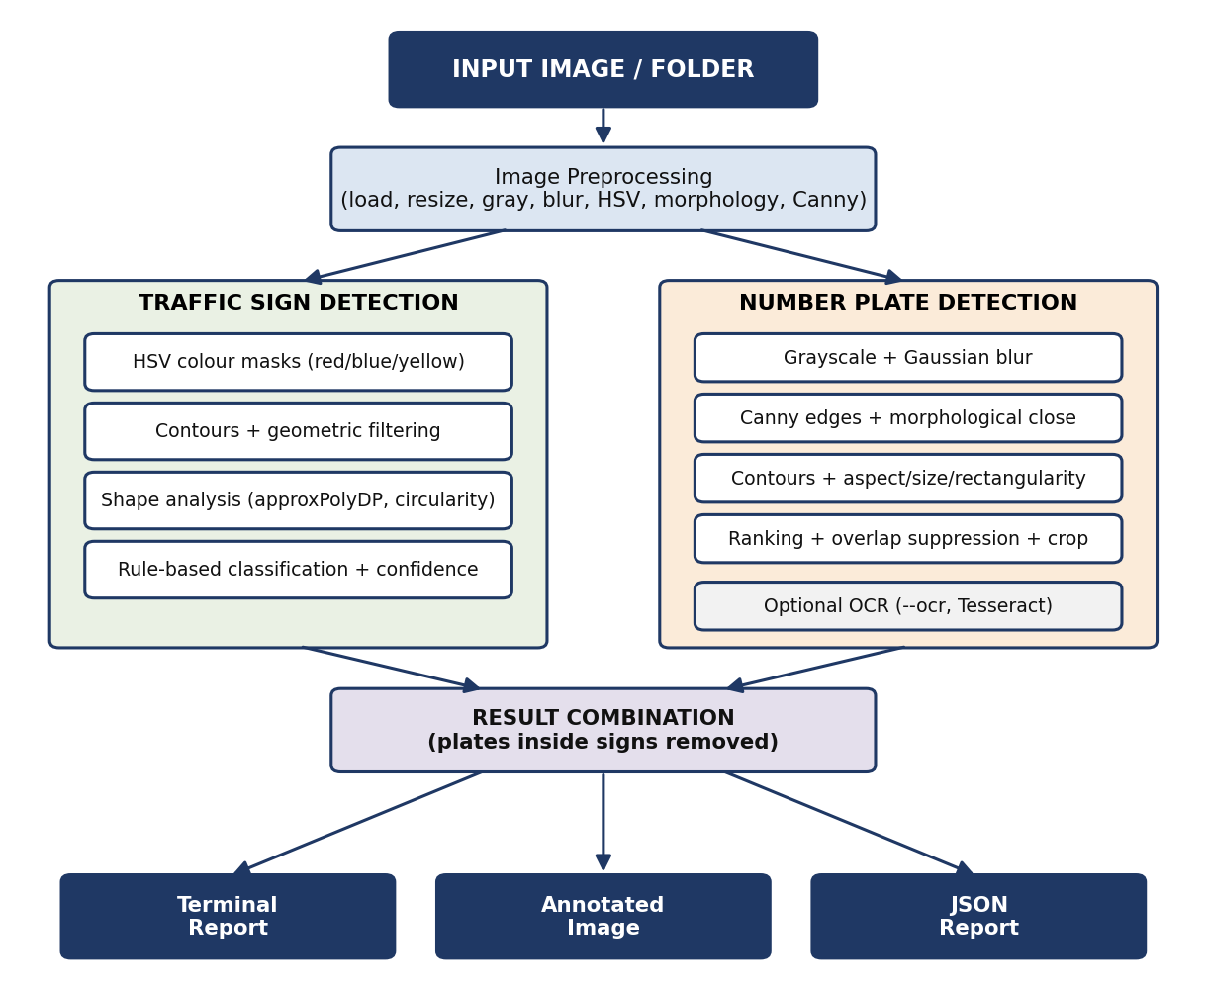
Figure 1: Overall architecture of Road Vision Analyzer

8.1 Module responsibilities
Table 4: Project modules
Module | Responsibility
main.py | Command-line interface (argparse), banner, warnings, exit codes
src/config.py | All tunable values: HSV ranges, sign and plate parameters, supported extensions, maximum processing size
src/preprocessing.py | Image loading/saving, resizing, grayscale, Gaussian blur, HSV conversion, Otsu threshold, morphology, Canny
src/traffic_sign.py | Colour masks, candidate search, shape analysis, interior features, rule-based classification, confidence
src/number_plate.py | Edge/contour pipeline, geometric filtering, heuristic ranking, overlap suppression, cropping
src/ocr.py | Optional OCR availability check, plate preprocessing for OCR, text cleaning
src/detection.py | Result combination, plates-inside-signs removal, annotated-image drawing
src/analyzer.py | Orchestration for one image or a whole folder; writes outputs and report.json
src/sample_data.py | Generator for synthetic demo/test images
src/utils.py | Exceptions, file discovery, geometry helpers (IoU), JSON saving, terminal formatting
tests/ | test_traffic_sign.py, test_number_plate.py, test_analyzer.py (20 pytest tests)

8.2 Project structure
road-vision-analyzer/
├── main.py
├── requirements.txt pytest.ini .gitignore
├── README.md PROJECT_REPORT.md
├── data/sample/ (8 synthetic demo images + README note)
├── outputs/ (detections/, plates/, report.json)
├── src/
│ ├── __init__.py config.py preprocessing.py
│ ├── traffic_sign.py number_plate.py ocr.py
│ ├── detection.py analyzer.py sample_data.py utils.py
└── tests/
├── test_traffic_sign.py test_number_plate.py test_analyzer.py

8.3 Design principles
- Separation of concerns — each module has one job; preprocessing code is not duplicated across detectors.
- Central configuration — thresholds live in frozen dataclasses (SignParams, PlateParams) and the HSV_RANGES table.
- Graceful failure — typed exceptions (ImageLoadError, InputNotFoundError, NoImagesFoundError, OutputError); one bad image never stops a batch.
- Optional dependencies — OCR is imported lazily and reports unavailable instead of failing.
- Honest output — UNKNOWN is returned instead of guessing; confidence is documented as heuristic.

9. Methodology
Each image passes through the same sequence of steps:
- Load — the file is read as bytes and decoded with OpenCV (this also works with non-ASCII Windows paths). Missing, empty and undecodable files raise ImageLoadError.
- Resize — if the longest side exceeds 1280 px the image is down-scaled (area interpolation); smaller images are left unchanged.
- Detect signs and detect plates — two independent detectors operate on the processed image (Sections 10 and 11).
- Combine — plate candidates whose box lies more than 60 % inside a detected sign are discarded; the two lists are merged into one result dictionary.
- Optional OCR — if --ocr is given, each plate crop is read with Tesseract; otherwise ocr_status is not_requested.
- Output — the annotated image (outputs/detections/<name>_annotated.jpg), plate crops (outputs/plates/), the terminal report, and outputs/report.json.
For folders, every supported file is processed in sorted order; unsupported files are ignored and failures are recorded in the report and in the batch summary. The project was developed iteratively: each detector was run on synthetic images, inspected visually, and its rules adjusted. Two concrete corrections made this way are described in Section 15.
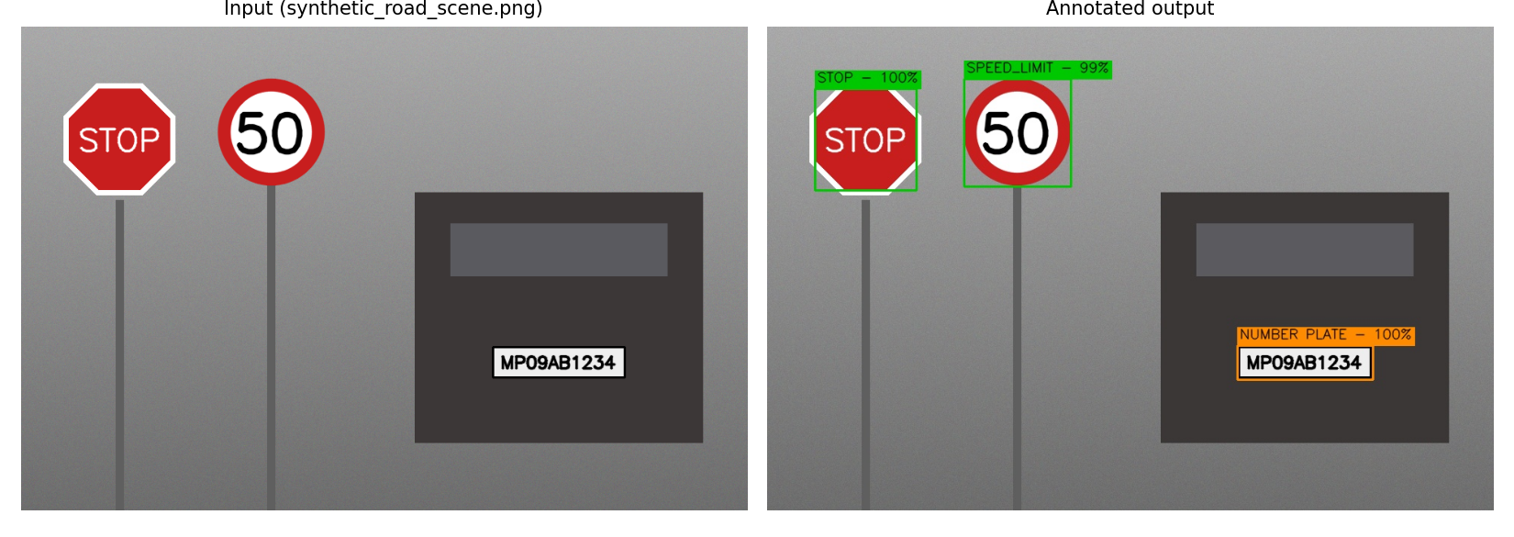
Figure 2: Example of the system input and its annotated output (synthetic road scene)

10. Traffic Sign Detection
Traffic sign detection combines colour segmentation, contour geometry and rule-based classification. The figure below shows the stages on the synthetic road scene.
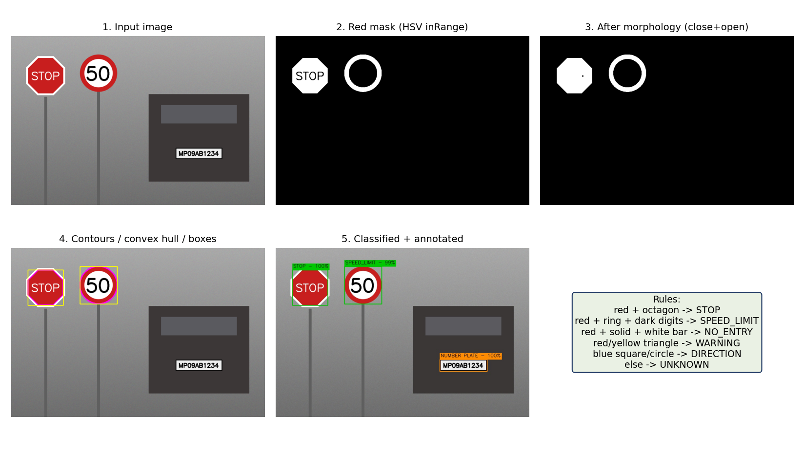
Figure 3: Traffic sign pipeline: HSV mask, morphology, contours, classification

10.1 Colour segmentation (HSV)
The image is lightly blurred (Gaussian 5×5) and converted from BGR to HSV, which separates colour (hue) from brightness and so is less sensitive to lighting than RGB thresholds. Each colour is described by one or more cv2.inRange ranges stored in config.HSV_RANGES. Red wraps around hue 0 and therefore has two ranges. OpenCV scales hue to 0–179 and saturation/value to 0–255.
Table 5: Configurable HSV ranges (src/config.py)
Colour | Lower (H, S, V) | Upper (H, S, V) | Typical signs
Red (range 1) | (0, 100, 70) | (10, 255, 255) | STOP, NO_ENTRY, SPEED_LIMIT, warning borders
Red (range 2) | (170, 100, 70) | (179, 255, 255) | same as above (hue wrap-around)
Blue | (100, 120, 50) | (130, 255, 255) | Direction / mandatory / information signs
Yellow | (18, 110, 110) | (35, 255, 255) | Warning signs

A high minimum saturation (100–120) is used so that pale blue sky and grey surfaces are not mistaken for sign colours.

10.2 Mask cleaning, contours and filtering
Each colour mask is cleaned with a morphological closing (fills holes such as the letters inside a STOP sign) followed by an opening (removes speckle). External contours are then extracted and a candidate is kept only if it passes all filters in the table below. Filtering is what removes "very small or unrealistic regions" without any hard-coded coordinates.
Table 6: Candidate filters for traffic signs (SignParams)
Filter | Value | Purpose
Contour area | 0.05 % – 50 % of image area | Reject specks and image-sized regions
Minimum side | 20 px | Reject tiny regions
Bounding-box aspect (w/h) | 0.5 – 2.5 | Reject very long thin shapes
Solidity (contour area / hull area) | ≥ 0.85 | Reject ragged or concave regions
Morphology kernel | 5 × 5 | Close holes, remove noise
Minimum confidence | 35 | Drop weak candidates
Overlap suppression | IoU > 0.4 or containment > 0.85 | Keep only the best of overlapping boxes

10.3 Shape analysis
For every candidate the convex hull is computed and described by three measures. The polygon is approximated with cv2.approxPolyDP using ε = 2 % of the perimeter, giving the number of sides. Circularity is 4πA / P². The circle ratio is the contour area divided by the area of its minimum enclosing circle.
The circle ratio is needed because polygon approximation alone cannot reliably separate a circle from an octagon (a circle can be approximated with a similar number of vertices). The ratio is about 1.0 for a circle, about 0.90 for a regular octagon, 0.64 for a square and 0.41 for an equilateral triangle, which gives a clear margin.
Table 7: Shape decision rules (tolerant, not mathematically exact)
Test (applied in order) | Shape
circularity ≥ 0.85 and circle ratio ≥ 0.93 | Circle
3 polygon sides | Triangle
4 sides; bounding-box aspect 0.85–1.18 / otherwise | Square / Rectangle
7 – 9 sides | Octagon
any other number of sides | Polygon

Excerpt: src/traffic_sign.py — analyze_shape()
if circularity >= params.circle_circularity and circle_ratio >= params.circle_ratio:
shape = "Circle"
elif sides == 3:
shape = "Triangle"
elif sides == 4:
shape = "Square" if 0.85 <= aspect <= 1.18 else "Rectangle"
elif 7 <= sides <= 9:
shape = "Octagon"
else:
shape = "Polygon"

10.4 Interior features
Inside each candidate shape the detector measures: the fraction covered by the colour mask (a solid disc versus a ring); the fraction of white pixels (low saturation, high value); the fraction of dark pixels in a central window (digits); and the white fraction in a central horizontal strip (the bar of a NO_ENTRY sign).

10.5 Rule-based classification
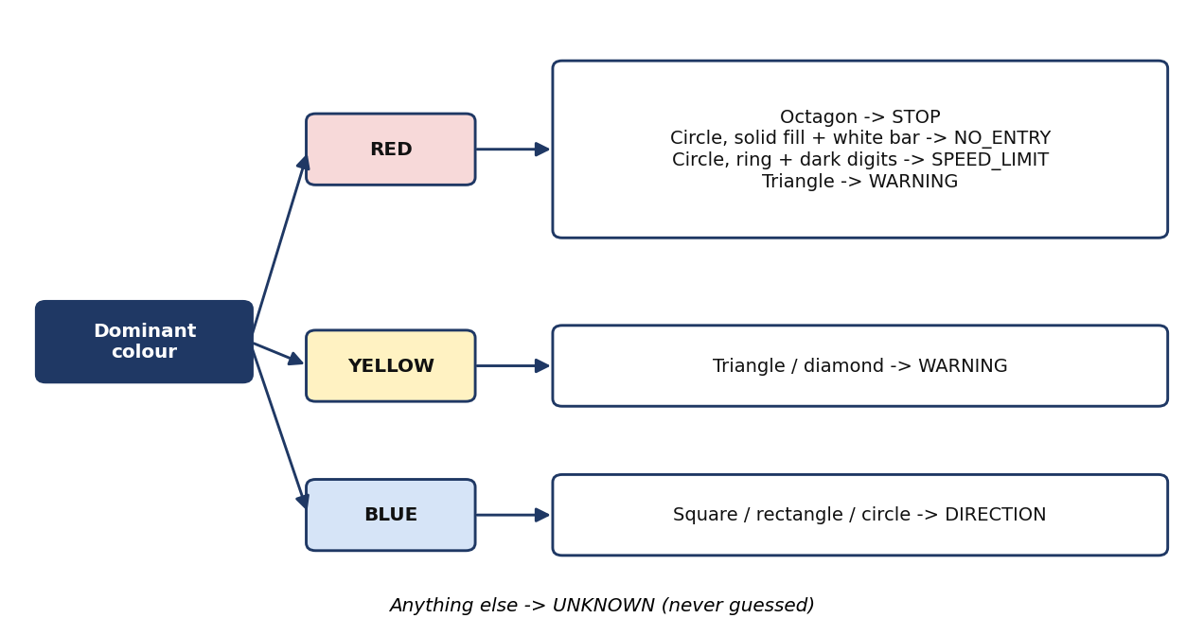
Figure 4: Decision rules of the sign classifier
Table 8: Sign classification rules
Type | Colour | Shape | Extra evidence
STOP | Red | Octagon | White text/pixels inside raise the evidence score
SPEED_LIMIT | Red | Circle (ring, fill < 60 %) | Dark pixels (digits) in the centre
NO_ENTRY | Red | Circle (solid, fill ≥ 60 %) | White horizontal bar across the centre
WARNING | Red or yellow | Triangle (yellow also square/diamond) | White interior (red border signs)
DIRECTION | Blue | Square, rectangle or circle | White symbol/arrow inside
UNKNOWN | any | anything else | Returned instead of guessing

The classifier does not claim to identify every real-world sign. Anything that does not match a rule is reported as UNKNOWN with its confidence halved and capped at 50.

10.6 Heuristic confidence
Confidence is a weighted sum of five evidence terms, scaled to 0–100. It is a rule-based heuristic score, not a machine-learning probability; it expresses how well a candidate satisfies the rules, not the chance that the label is correct.
Table 9: Traffic sign confidence components
Component | Weight | Definition
Contour quality | 0.20 | Solidity mapped from 0.80–1.00 to 0–1
Shape match | 0.20 | 1.0 if the shape is expected for the type, else 0.3
Colour coverage | 0.20 | Colour-mask fraction inside the shape ÷ 0.4 (capped at 1)
Size / aspect | 0.10 | Half aspect-ratio closeness to 1, half relative size
Rule evidence | 0.30 | 1.0 for a full rule match, 0.6–0.8 for a partial match, 0 for UNKNOWN

11. Number Plate Detection
Plate detection exploits the fact that a plate is a wide rectangle with dense, high-contrast edges from its border and characters. The twelve processing steps of the specification map directly onto the implementation in src/number_plate.py.
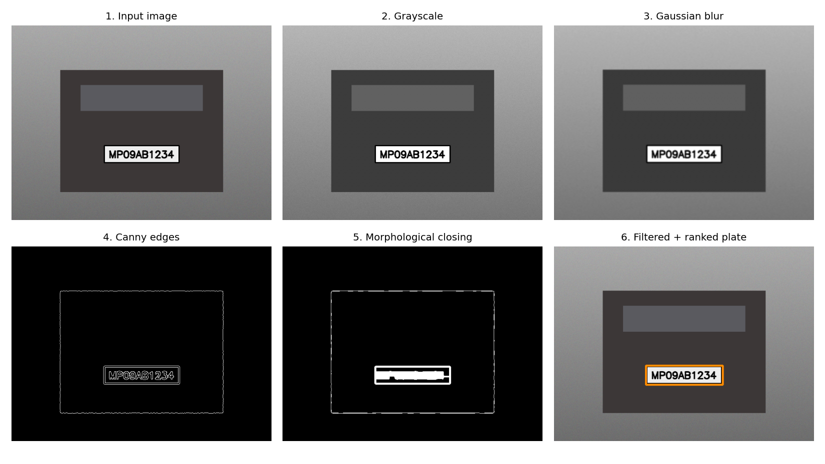
Figure 5: Number plate pipeline from input to the ranked plate
Table 10: Plate detection steps
Step | Operation | Implementation
1–2 | Read image; convert to grayscale | preprocessing.load_image, to_gray
3 | Gaussian blur (5×5) | preprocessing.gaussian_blur
4 | Canny edges (thresholds 50 / 150) | preprocessing.detect_edges
– | Morphological closing with a wide, short kernel (joins characters and border into one blob) | preprocessing.morph_close
5–7 | Find contours (all, so plates nested inside a car outline are found); bounding rectangles | cv2.findContours(RETR_LIST), boundingRect
6, 8, 9 | Filter by width (7–50 % of image width), height (≥ 12 px), aspect ratio (2.0–6.5), rectangularity (≥ 0.45) | find_plate_candidates
10–11 | Score, rank, suppress overlaps (IoU > 0.3), keep up to 3 with confidence ≥ 50 | detect_number_plates
12–13 | Crop with 4 px padding and save | crop_plate, analyzer.analyze_image

11.1 Heuristic confidence
Table 11: Number plate confidence components
Component | Weight | Ideal range / definition
Aspect-ratio suitability | 0.25 | Full score for width/height between 2.5 and 5.5
Contour (area) size | 0.15 | Full score when the plate covers 0.4 % – 8 % of the image
Rectangularity | 0.25 | Contour area ÷ bounding-box area, mapped from 0.45–0.90
Edge density | 0.25 | Full score for 6 % – 35 % edge pixels inside the box
Position | 0.10 | Full score when the box centre is between 35 % and 95 % of image height

As with signs, this is a heuristic score between 0 and 100 and not a learned probability.

11.2 Result combination
Text and bars on signs have plate-like proportions: during development the word STOP, the "50" of a speed-limit sign and the white bar of a NO_ENTRY sign were reported as plates. The result-combination step therefore removes any plate candidate whose box is more than 60 % inside a detected sign. A larger minimum plate width (7 % of the image width) also removes character-group fragments.

11.3 Output per plate
Each detected plate returns detected, bounding_box (x, y, width, height), area, aspect_ratio, confidence, the saved crop path (plate_image), ocr_text and ocr_status.

12. OCR Module
OCR is optional. When --ocr is given, src/ocr.py checks that both pytesseract and the Tesseract binary are available. If either is missing, a warning is printed, plate detection continues, and the plate result contains "ocr_text": null and "ocr_status": "unavailable". No text is ever fabricated.
Before recognition the crop is preprocessed: grayscale, up-scaling, non-local-means denoising, Otsu thresholding with a polarity check (dark text on light background), morphological opening and a white border. Tesseract is run in single-line mode (--psm 7) with an upper-case letters-and-digits whitelist, and the result is cleaned to [A-Z0-9].
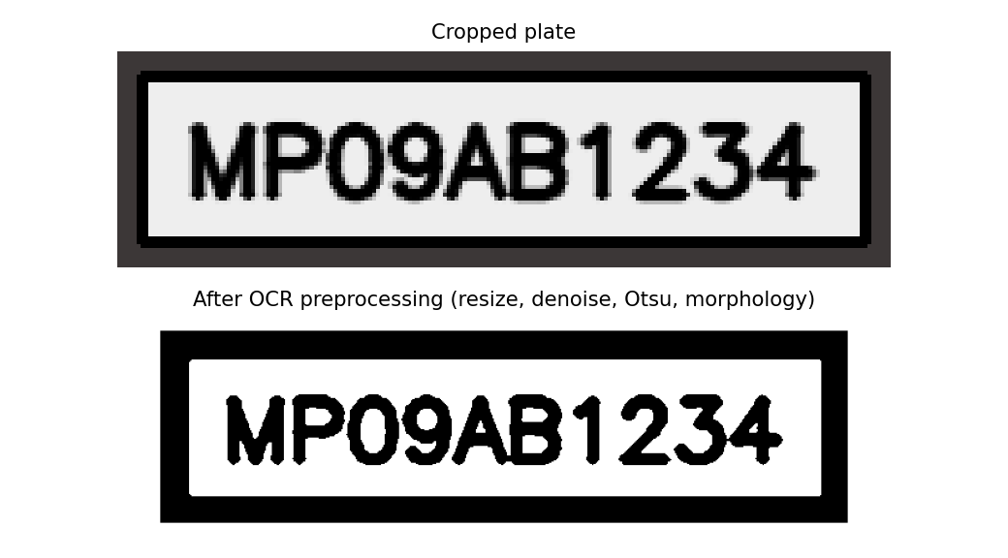
Figure 6: Cropped plate and its OCR-preprocessed version
Table 12: OCR status values
ocr_status | Meaning
not_requested | --ocr was not supplied
ok | Text recognised and returned in ocr_text
no_text | OCR ran but found no usable characters
unavailable | pytesseract or the Tesseract engine is not installed
error | OCR raised an unexpected error

Measured behaviour. On the synthetic plate "MP09AB1234" Tesseract returned MPO9AB1234 — the digit 0 was read as the letter O. OCR is therefore reported as imperfect and optional.

13. Algorithms
Table 13: Algorithms used
Algorithm / technique | OpenCV function | Used for
Colour-space conversion | cvtColor (BGR→HSV, BGR→GRAY) | Lighting-tolerant colour segmentation; edge input
Range thresholding | inRange | Red / blue / yellow masks
Gaussian smoothing | GaussianBlur | Noise reduction before masks and edges
Morphological closing / opening | morphologyEx | Fill holes, remove speckle, join plate characters
Border following (Suzuki–Abe) | findContours | Candidate region extraction
Convex hull | convexHull | Robust shape description; solidity
Douglas–Peucker approximation | approxPolyDP | Counting polygon sides
Minimum enclosing circle | minEnclosingCircle | Circle versus octagon discrimination
Canny edge detection | Canny | Plate edge map
Non-maximum suppression (IoU, containment) | custom, utils.suppress_overlaps | Removing duplicate or nested detections
Otsu thresholding | threshold(THRESH_OTSU) | Binarising the plate for OCR
Non-local-means denoising | fastNlMeansDenoising | OCR preprocessing

Key formulas: circularity = 4πA / P²; circle ratio = A / (π r²) with r the minimum enclosing radius; solidity = A / A_hull; rectangularity = A_contour / (w × h); IoU = |A ∩ B| / |A ∪ B|.

14. Implementation

14.1 Command-line interface
Table 14: CLI options
Option | Description
--input, -i | Path to an image or a folder of images (required unless --generate-samples)
--output, -o | Output directory (default outputs)
--ocr | Try to read plate text with pytesseract; warns and continues if unavailable
--generate-samples | Create the synthetic demo images and exit (unless --input is also given)
--sample-dir | Folder for generated samples (default data/sample)

The program returns exit code 0 on success and 1 on fatal errors (missing input, empty folder, no image could be processed).

14.2 Error handling
Table 15: Error conditions and behaviour
Condition | Behaviour | Checked by
Missing input path | [ERROR] Input path does not exist, exit code 1 | CLI run, unit test
Missing / invalid / corrupted / empty image | ImageLoadError; in a batch the image is recorded as failed and the run continues | Unit tests
Unsupported file type | Clear message listing supported extensions | Unit test
Empty folder (no supported files) | NoImagesFoundError message, exit code 1 | CLI run, unit test
Output directory cannot be created | OutputError message, exit code 1 | CLI run
OCR unavailable | Warning, detection continues, ocr_status: unavailable | Unit test, simulated run
No signs / no plates found | "(no traffic signs found)" / "(no number plates found)" | Empty-road sample

14.3 Output formats
Annotated images are saved to outputs/detections/ (green boxes for signs with "TYPE - confidence %", orange boxes for plates with "NUMBER PLATE - confidence %" and OCR text when available). Plate crops go to outputs/plates/. The JSON report outputs/report.json is a list with one entry per image; examples are given in Appendices C and D.

14.4 Synthetic sample data
src/sample_data.py draws eight demonstration images with OpenCV (a red octagonal STOP-like sign, circular speed-limit-like and no-entry-like signs, a red-bordered triangular warning-like sign, a blue square direction-like sign, a car body with a rectangular plate, a combined scene and an empty road). They are labelled as synthetic in data/sample/README.md and are not real road photographs.
Excerpt: src/config.py — centralised HSV thresholds
HSV_RANGES = {
"red": [((0, 100, 70), (10, 255, 255)), ((170, 100, 70), (179, 255, 255))],
"blue": [((100, 120, 50), (130, 255, 255))],
"yellow": [((18, 110, 110), (35, 255, 255))],
}

Excerpt: src/number_plate.py — heuristic plate confidence
def compute_plate_confidence(aspect, area_ratio, rectangularity, edge_density, center_y_ratio):
aspect_score = _range_score(aspect, 2.5, 5.5, 2.0)
area_score = _range_score(area_ratio, 0.004, 0.08, 0.04)
rect_score = _clip01((rectangularity - 0.45) / 0.45)
edge_score = _range_score(edge_density, 0.06, 0.35, 0.15)
position_score = 1.0 if 0.35 <= center_y_ratio <= 0.95 else 0.6
score = (0.25 * aspect_score + 0.15 * area_score + 0.25 * rect_score
+ 0.25 * edge_score + 0.10 * position_score)
return round(100.0 * score, 1)

15. Experimental Results
Important. All results below come from the eight synthetic images generated by this project (deterministic random seeds). The images are clean, front-facing and drawn by the same author as the detection rules. These results show that the pipeline works as designed; they do not measure accuracy on real road photographs, and no accuracy, precision or recall figures are claimed. Confidence values are heuristic scores.

15.1 Setup
Command: python main.py --input data/sample --output outputs. Environment: Python 3.12.3, OpenCV 4.13.0, NumPy 2.4.4. Coordinates are (x, y, width, height) in pixels of the processed image.

15.2 Per-image results
Table 16: Expected versus detected results on the synthetic images
Image | Expected | Detected | Sign conf. | Sign box | Plate conf. (box) | Result
synthetic_stop_sign | STOP | STOP (Octagon, Red) | 100.0 | (228, 98, 184, 184) | — | Match
synthetic_speed_limit | SPEED_LIMIT | SPEED_LIMIT (Circle, Red) | 99.5 | (215, 85, 211, 212) | — | Match
synthetic_no_entry | NO_ENTRY | NO_ENTRY (Circle, Red) | 99.5 | (220, 90, 201, 202) | — | Match
synthetic_warning | WARNING | WARNING (Triangle, Red) | 98.0 | (218, 92, 204, 180) | — | Match
synthetic_direction | DIRECTION | DIRECTION (Square, Blue) | 100.0 | (225, 95, 191, 191) | — | Match
synthetic_number_plate | 1 plate | 1 plate, aspect 4.02 | — | — | 100.0 (226, 294, 189, 47) | Match
synthetic_road_scene | STOP, SPEED_LIMIT, 1 plate | STOP, SPEED_LIMIT, 1 plate (aspect 3.98) | 100.0 / 99.3 | (63, 83, 134, 134) / (260, 70, 141, 142) | 100.0 (621, 422, 179, 45) | Match
synthetic_empty_road | nothing | nothing | — | — | — | Match

All eight images produced the expected result: 7 traffic signs and 2 number plates in total, 8 of 8 images processed, 0 failed. The empty-road image correctly produced no detections.
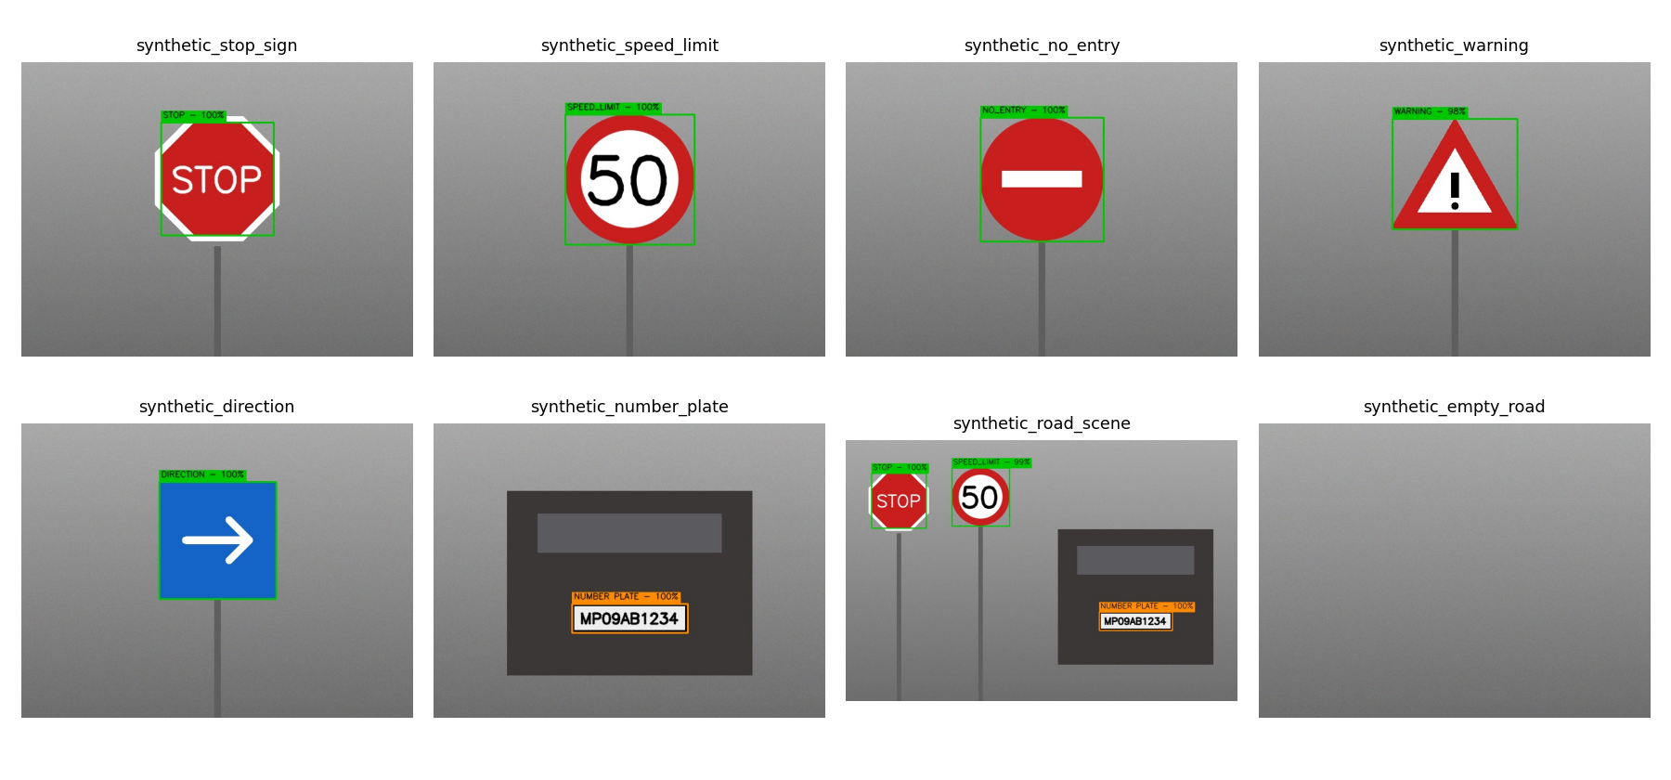
Figure 7: Annotated detection results for all eight synthetic images
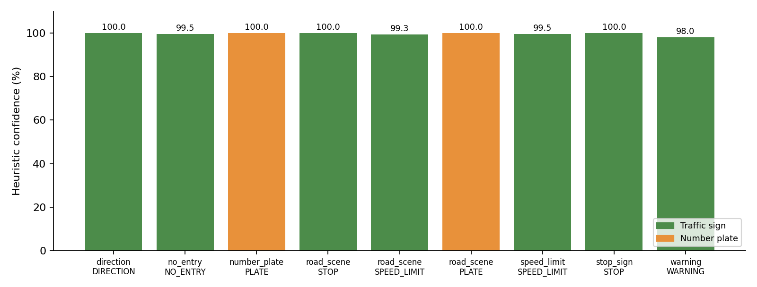
Figure 8: Heuristic confidence of every detection (synthetic images)
Confidence values are close to 100 because the synthetic images are clean and match the rules well; on real photographs lower and more varied values would be expected.

15.3 Batch summary (measured)
BATCH SUMMARY
---------------------------------------------
Images found : 8
Images processed : 8
Images failed : 0
Traffic signs : 7
Number plates : 2

15.4 OCR result
With OCR enabled and Tesseract installed, the synthetic plate "MP09AB1234" was read as MPO9AB1234: nine of ten characters were correct and the digit 0 was read as the letter O. This single run is not a statistical measurement; it only illustrates the typical letter/digit confusion.

15.5 Observations and corrections made during development
- Plates nested in a car outline. With external-only contours the plate inside the car-body outline was missed; using all contours (RETR_LIST) fixed this.
- False plates on signs. The text and bars on signs were first reported as plates (for example the white bar of the NO_ENTRY sign at 100 % confidence). Removing plates inside detected signs and raising the minimum plate width to 7 % of the image width fixed this.
- Demo-image drawing. The first synthetic STOP text and plate text overflowed their shapes; the font scale was adjusted so the demo data represents the intended objects.
- Circle versus octagon. Polygon-side count alone was not reliable for circles, so the circle-ratio test was added.

16. Testing
The test suite uses pytest, runs in under two seconds, needs no internet connection and uses only the synthetic images generated in memory or in temporary folders. All 20 tests passed at the time of writing (20 passed).
Table 17: Automated tests
File | Tests | What is verified
test_traffic_sign.py | 8 | Candidate detection for a STOP scene (red candidate found).  Classification of the five synthetic sign types (5 parametrised cases: type and shape).  Result structure (type, shape, color, confidence, bounding_box) and confidence range 0–100.  No signs in an empty or black image.
test_number_plate.py | 5 | Plate candidates exist; detected plate has valid structure, aspect ratio and area.  Detected location is close to where the plate was drawn.  Cropping returns a valid image.  No plates in empty or black images.
test_analyzer.py | 7 | Complete result structure and saved annotated image.  Missing image / input raises the proper error.  Invalid, corrupted and empty image files.  Unsupported file and empty folder.  Batch of 9 files with one corrupted file: 8 processed, 1 failed, 7 signs, 2 plates; JSON report valid.  OCR unavailable never fabricates text (mocked).  CLI success (exit 0) and failure (exit 1, [ERROR] on stderr).

16.1 Manual verification
Table 18: Verification commands run
Command | Outcome
python main.py --input data/sample | Completed; 8 images processed, 0 failed
python main.py --input data/sample --output outputs | Completed; outputs/report.json, outputs/detections/, outputs/plates/ generated
pytest | 20 passed
python main.py --input nope.jpg | [ERROR] Input path does not exist, exit code 1
python main.py --input <empty folder> | [ERROR] No supported images ... found in folder, exit code 1
python main.py --input <image> --output /proc/xx/yy | [ERROR] Cannot create output directory, exit code 1
python main.py --input <plate image> --ocr | OCR text returned when Tesseract is installed; warning and continued detection when it is not

17. Limitations
- Synthetic evaluation only. The system has been verified on synthetic images and unit tests, not on real road photographs; real-world accuracy is unknown.
- Lighting and colour. Fixed HSV ranges are sensitive to illumination, colour casts, faded paint and shadows; red or blue objects that are not signs (vehicles, clothing, sky, advertising) can produce candidates.
- Geometry. Signs are assumed roughly front-facing; strong perspective, rotation, partial occlusion and motion blur are not handled.
- Limited sign vocabulary. Only a handful of simple patterns are recognised; other signs are reported as UNKNOWN or missed. Speed-limit values are not read.
- Plate detection is geometric. Any wide rectangle with dense edges (billboards, windows, grilles) can be a false positive; plates narrower than about 7 % of the image width or strongly tilted are likely to be missed.
- Plates inside signs are discarded by design, which would also hide a real plate that happens to lie inside a sign box.
- Heuristic confidence. Scores are uncalibrated rule-based values that saturate near 100 on clean synthetic images; they are not probabilities.
- OCR is optional and error-prone, especially for small, blurred or tilted plates, and confuses similar letters and digits (for example O and 0).
- Resolution handling. Images larger than 1280 px are down-scaled; coordinates in the report refer to the processed image.

18. Future Scope
- Evaluate on labelled real-world datasets (for example GTSRB / GTSDB for signs) and report precision and recall.
- Add illumination-robust colour handling (adaptive thresholds, colour constancy) and perspective correction.
- Recognise sign symbols and speed-limit digits using template or feature matching, or a trained classifier, while keeping the rule-based version as a baseline.
- Segment plate characters and validate plate formats to improve OCR accuracy.
- Support video input with temporal smoothing and tracking.
- Calibrate the confidence scores against measured accuracy.

19. Conclusion
Road Vision Analyzer demonstrates a complete, explainable Computer Vision pipeline built from classical techniques: HSV colour segmentation, morphological cleaning, contour and shape analysis and a rule-based classifier for traffic signs; Canny edges, contour filtering and geometric ranking for number plates; and an optional, safely isolated OCR stage. The system is modular, configurable from one place, fully offline and usable from the command line, and it produces annotated images, a terminal report and a JSON report with robust error handling.
On the eight synthetic demonstration images every sign and plate was found and classified as designed (7 signs, 2 plates, 0 failures), and all 20 automated tests pass. These results confirm that the implementation works as specified; they do not establish performance on real road imagery, which remains untested and is the main direction for future work. The project documents its heuristic confidence scores, its limitations and the corrections made during development openly, so that every design decision can be explained and defended.

20. References
- Bradski, G. (2000). The OpenCV Library. *Dr. Dobb's Journal of Software Tools*. Documentation: https://docs.opencv.org
- Harris, C. R., et al. (2020). Array programming with NumPy. *Nature*, 585, 357–362.
- Canny, J. (1986). A computational approach to edge detection. *IEEE Transactions on Pattern Analysis and Machine Intelligence*, 8(6), 679–698.
- Suzuki, S., & Abe, K. (1985). Topological structural analysis of digitized binary images by border following. *Computer Vision, Graphics, and Image Processing*, 30(1), 32–46.
- Douglas, D., & Peucker, T. (1973). Algorithms for the reduction of the number of points required to represent a digitized line or its caricature. *Cartographica*, 10(2), 112–122.
- Otsu, N. (1979). A threshold selection method from gray-level histograms. *IEEE Transactions on Systems, Man, and Cybernetics*, 9(1), 62–66.
- Stallkamp, J., Schlipsing, M., Salmen, J., & Igel, C. (2012). Man vs. computer: Benchmarking machine learning algorithms for traffic sign recognition. *Neural Networks*, 32, 323–332. (Suggested dataset for future evaluation; not used in this project.)
- Tesseract OCR engine: https://github.com/tesseract-ocr/tesseract
- pytest documentation: https://docs.pytest.org

Appendix A: Requirements Traceability
This table maps the requirements of the project specification to the implementation, so that every requirement can be checked.
Table 19: Requirement traceability matrix
Requirement | Where implemented | Status / evidence
CLI: single image, folder, --output, --ocr | main.py (argparse) | Implemented; run and tested
Core uses only OpenCV, NumPy, pytest; OCR optional | requirements.txt; lazy import in ocr.py | Implemented; OCR-unavailable test
HSV red/blue/yellow thresholds in a dedicated module | config.HSV_RANGES | Implemented
Morphology, contours, filtering, approxPolyDP, circularity, bounding boxes | traffic_sign.py | Implemented; sign tests
Shape names: Triangle, Square/Rectangle, Polygon, Circle, Octagon | analyze_shape | Implemented
Categories STOP, SPEED_LIMIT, NO_ENTRY, WARNING, DIRECTION, UNKNOWN | classify_sign | Implemented; UNKNOWN never guessed
Heuristic sign confidence 0–100, documented as not ML probability | compute_confidence; README; this report | Implemented and documented
Plate pipeline: gray, blur, Canny, contours, area/aspect/size filters, ranking, crop, save | number_plate.py, analyzer.py | Implemented; plate tests
Plate fields: x, y, width, height, area, aspect ratio, confidence, detected | bounding_box, area, aspect_ratio, confidence, detected | Implemented (x, y, width, height inside bounding_box)
Heuristic plate confidence from aspect, area, rectangularity, edge density, position | compute_plate_confidence | Implemented and documented
Optional OCR with preprocessing; ocr_text / ocr_status; never fabricate | ocr.py | Implemented; Tesseract run once
Reusable preprocessing module | preprocessing.py | Implemented
Annotated images in outputs/detections/ | detection.draw_annotations | Implemented; 8 images generated
JSON report outputs/report.json | analyzer.analyze_input | Implemented; validated by test
Professional terminal output and batch summary | utils.format_* | Implemented
Supported formats .jpg .jpeg .png .bmp .webp; ignore others | config, utils.collect_images | Implemented; tested
Error handling (missing, invalid, corrupted, empty folder, unsupported, output dir, OCR, no detections) | utils exceptions; analyzer | Implemented; tested
Modular structure | src/ modules | Implemented (extra: config.py, sample_data.py, pytest.ini)
pytest tests (at least 6–10) | tests/ | 20 tests, all pass
Synthetic sample data, clearly labelled | sample_data.py, data/sample/README.md | Implemented
README, PROJECT_REPORT, requirements, .gitignore | project root | Created
No unsupported claims (accuracy, "AI-powered", datasets) | README; this report | Followed
Final verification commands | Section 16.1 | Run; results reported

Noted deviations. Reported coordinates refer to the processed (possibly down-scaled) image; extra optional fields (status, error, image_size, plate_image, polygon_sides) were added to the JSON; the Author section of the README is a placeholder to be completed by the student.

Appendix B: How to Run
Installation and commands
python -m venv .venv
.venv\Scripts\activate # Linux/macOS: source .venv/bin/activate
pip install -r requirements.txt

python main.py --generate-samples # create synthetic demo images
python main.py --input data/sample # batch
python main.py --input data\sample\synthetic_warning.png # single image (Windows path)
python main.py --input image.jpg --output outputs
python main.py --input image.jpg --ocr # optional OCR
pytest # run the 20 tests

For OCR install pytesseract and the Tesseract engine (Windows installer: https://github.com/UB-Mannheim/tesseract/wiki; Ubuntu: sudo apt install tesseract-ocr; macOS: brew install tesseract).

Appendix C: Sample Terminal Output
Real output for synthetic_road_scene.png:
=============================================
ROAD VISION ANALYZER
=============================================

Input: synthetic_road_scene.png

TRAFFIC SIGNS
---------------------------------------------
Detected: 2

[1]
Type : STOP
Shape : Octagon
Color : Red
Confidence : 100%
Location : (63, 83, 134, 134)

[2]
Type : SPEED_LIMIT
Shape : Circle
Color : Red
Confidence : 99%
Location : (260, 70, 141, 142)

NUMBER PLATES
---------------------------------------------
Detected: 1

[1]
Confidence : 100%
Location : (621, 422, 179, 45)
Aspect Ratio : 3.98
OCR : Not requested

---------------------------------------------
Annotated image saved:
outputs/detections/synthetic_road_scene_annotated.jpg

Appendix D: Sample JSON Report Entry
{
"image": "synthetic_number_plate.png",
"status": "ok",
"error": null,
"image_size": { "width": 640, "height": 480 },
"traffic_signs": [],
"number_plates": [
{
"detected": true,
"confidence": 100.0,
"bounding_box": { "x": 226, "y": 294, "width": 189, "height": 47 },
"area": 8883,
"aspect_ratio": 4.02,
"plate_image": "outputs/plates/synthetic_number_plate_plate1.png",
"ocr_text": null,
"ocr_status": "not_requested"
}
],
"annotated_image": "outputs/detections/synthetic_number_plate_annotated.jpg"
}

Table 20: Fields of a traffic sign entry
Field | Meaning
type | STOP, SPEED_LIMIT, NO_ENTRY, WARNING, DIRECTION or UNKNOWN
shape | Circle, Octagon, Triangle, Square, Rectangle or Polygon
color | Red, Blue or Yellow (dominant segmentation colour)
confidence | Heuristic score 0–100 (not a probability)
bounding_box | x, y, width, height in pixels of the processed image
polygon_sides | Number of sides from polygon approximation

